Gender Differences
Student’s Name
Institution’s Affiliation
Gender Differences
Abstract
This research project focused on determining whether there exists any relationship between gender and the ability to remember and store information over time. In order to make this research work more ethical and significantly, a balanced number of males and females’ representatives were used. The hypothesis of the study was done and tested through sampling. A set of words were given to the participants through the speaking and listening method. The list mixed both shorter words and longer words such as “orange”. The words that each participant managed to recall and the gender of the participant was recorded in a Microsoft Excel, and two sample means t-tests were used for analysis. The results obtained indicated that no significant difference was observed between males and females. The t-value was found to be lower than the critical t-value. After the test, we noted that men could show high and accurate responses in huge numbers and a very little difference was also noted from their counterparts. We estimated that there existed some differences between the genders and the general acts according to different levels of their cognitive ability, both male and females will perform almost equally and they will prove no huge statistical differences.
Introduction.
Ability to recall is a critical aspect of our lives. Memory is used in all areas of our life, such as family enhancements, work stations, and relationships (Lourenco et al., 2019). Some people have memory issues, and they take long to recall things like dates and time of specific events, colleagues’ names, and also their friends’ favorite colors. Results showed that females performed well in verbal episodic memory abilities such as recalling dates, items, images, and life occasions whereas men overtook women in recollecting symbols and content not related to language. Since our study was limited to episodic verbal tasks in mind, we postulated that the woman members would excel academically than men. From the information we collected during the study, remedial actions can be created and utilized, including playing in the study space (Lourenco et al.,2019). However, memory custody between the two genders can be studied in a more profound way to configure which gender can accurately recall and why the other gender would recall inadequately.
Method section
The data collection methods were to determine the total words every participant would recall in our list of 26 words in not more than two minutes. The study entailed different participants such as friends, family members, and colleagues in a work station who were selected randomly. From the respective group members, a person was mandated to obtain facts from 10 partakers, which led to 50 members in total. From every set of ten members, five females and males were selected and therefore, in the 50 participants, 25 were males, and 25 were females. Gender balance aimed to help truly determine if women have good retention memory than men or vice versa.
Results
The research showed that indeed, females would have advanced oral episodic memory retaining ability than the men. The results obtained during the study are as follows: average words by the women were 8.36, average male word remembered were 8.90, woman range 14, men showed a range of 8, woman’s variance 7.82, men’s variance 7.14. The expressive figures led to the postulation that males’ outcome was greater with generally less variation as well as range. Less range and variance would show a higher level of uniformity in the gender’s feedbacks. A trial was then done to decide the importance of the results that were given. After our group t-test, the results show that the hypothesis established to females having advanced oral episodic memory than the males were disqualified and termed inappropriate and not statistically substantial. However, from our trial, our t-score shows 0.584 through a critical value from two tests set at 2.062 and an ap value of 0.563. The results show that male marks average to be 0.46 points above the women. Lastly, our testing shows no great statistical dissimilarity between the two genders as indicated by our p-value which is directly above the established level of 0.05.
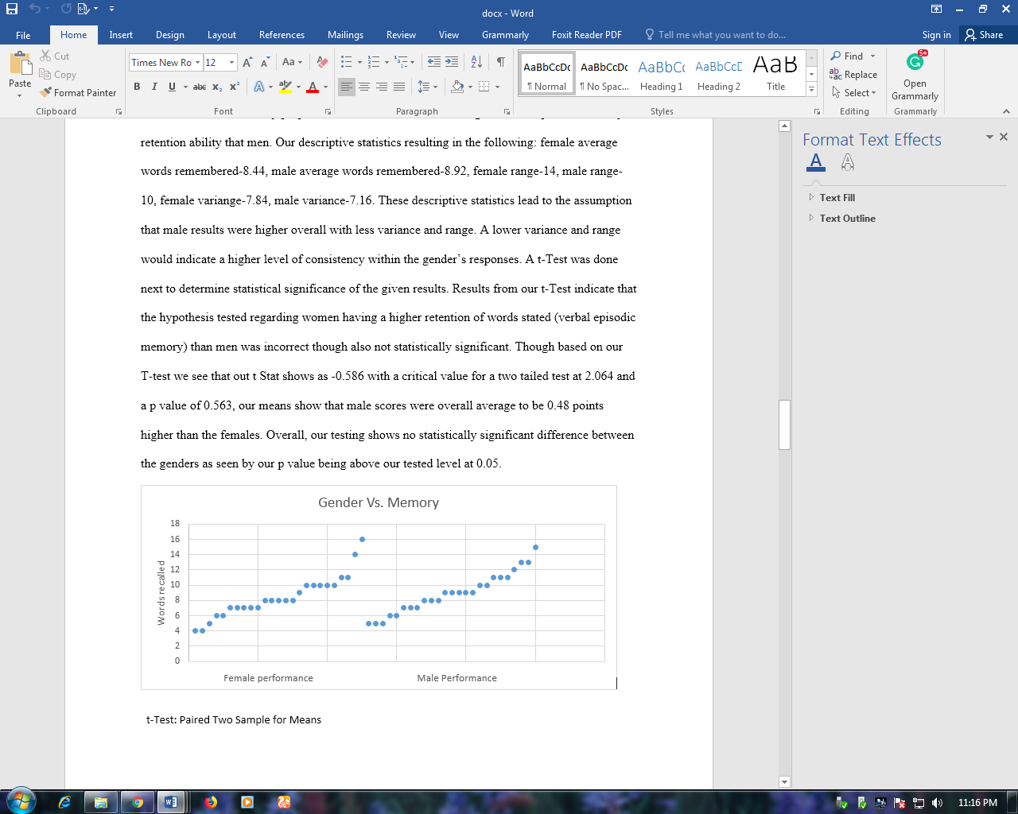
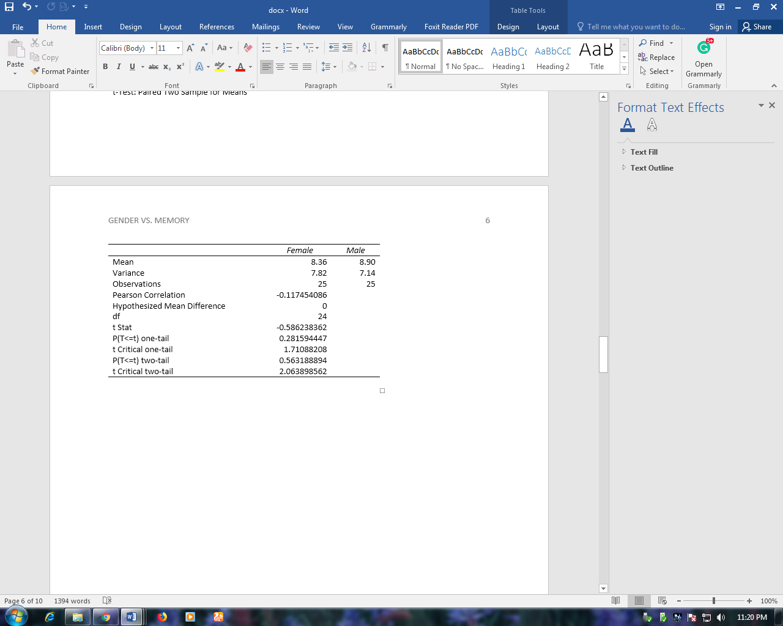

Discussion
Several factors also affect the true nature and memory ability (Rehnman et al., 2011). One of the outlying factors that were omitted during the study was the participants' oldness or rather age. Since we didn’t track the ages of members, this could at least shake our results. An additional parameter that was not put into consideration is the environment. The environment has an effect on memory ability, which is associated with gender. Several studies, even at the neural level, shows that environmental factors and areas of upbringing affect everything at a neural level, which then affects the human ability to recall (Rehnman et al.,2011). A study of one day old kids found that indeed baby boys gazed to give attention to three dimensional mobile devices much lengthier than the girls, while the girls observed at the peoples face appearances for much longer than the boys. Articles on gender differences show that there is a gender variance in awareness and memory interests through ought the lifespan right from day one, but also the environment and upbringing can influence memory ability. Women show variation over their spatial abilities depending on the stage they in throughout the menstrual cycle, and also there is a report that abilities either in men or women may be affected by the amount of testosterone hormone that goes into the womb during fetal development until the period of birth (Saint-Aubin et al., 2017). Additionally, children who receive too much testosterone while in the womb develops language in late years and they have very few vocabularies at the age of around two years. From our findings, we consider that even though there are variances in the memory ability between the genders, it is not significant in this small research study. When looked from a broader perspective and in accordance with our research work, we are likely to note the significance of gender abilities and genders effect on memory. In addition, several psychologists have come up with new discoveries that women often perform well in responsibilities requiring little or no oral processing than men. Females are subjected to better episodic memory, which increases their ability to utilize verbal abilities. Surrounding factors, such as education, experiences, and exposure tend to increase the scale of sex differences and memory differences (Rehnman et al.,2011). The following factors; hormones level, environment, upbringing, and age influence the memory ability within genders.
Conclusion.
Our group hypothesis during our research work was that females have an impressive oral episodic memory than the males, especially during a task of remembering the dictated words. The study considered small sample people where the participants were selected randomly to avoid biases and to enhance the equal representation of both genders. Memory recall plays a vital role in every slice of human lives and in their lifetime. This includes recalling birthday dates, meeting dates, anniversaries, spouse favorite colors, and anniversaries. The study showed minimal differences between the genders when it comes to remembering the auditorial words of three to six characters. During the research study, age, environment, hormonal factors, and upbringing were considered as extraneous variables.

REFERENCES
Gender Differences. (2018, November 09). Retrieved from About Memory: https://www.memory-key.com/memory/individual/gender
Lauer, J. E., Yhang, E., & Lourenco, S. F. (2019). The development of gender differences in spatial reasoning: A meta-analytic review. Psychological Bulletin, 145(6), 537.
Lovén, J., Herlitz, A., & Rehnman, J. (2011). Women’s own-gender bias in face recognition memory. Experimental psychology.
Voyer, D., Voyer, S. D., & Saint-Aubin, J. (2017). Sex differences in visual-spatial working memory: A meta-analysis. Psychonomic bulletin & review, 24(2), 307-334

